**Societies Foreign Trip Proposal**

This form must be completed and submitted **at least two months** prior to your departure for your trip to go ahead.

Please email a completed copy to both [societiesofficer@uccsocieties.ie](mailto:societiesofficer@uccsocieties.ie), [finance@uccsocieties.ie](mailto:finance@uccsocieties.ie) and [president@uccsocieties.ie](mailto:president@uccsocieties.ie) for approval.

**For a Foreign Trip under UCC Societies:**

1. It is very important that you justify the reason for your trip. There must be a **developmental benefit** of the trip to the society. Your proposal needs to show that you are operating at a high level domestically and wish to develop further by traveling abroad. It must show that you are bringing members who are invested and involved and whose knowledge/skills will be enhanced by the trip. The trip is not a holiday, you are always representing your society and UCC.
2. You will be emailed once approved/rejected. This means that the trip has been passed by the Societies Executive and is approved in principle. **If approved in principle, you must then submit the risk assessment to** [**healthandsafety@uccsocieties.ie**](mailto:healthandsafety@uccsocieties.ie)**.** This must be submitted at least one month prior to the travel date. It is advised that you provide the trip proposal & risk assessment in good time- the later the approval the later you get to book your flights/ferry, and this of course will result in higher prices. The trip is not officially approved until the risk assessment is approved. If you intend to seek funding for the trip, the funding request should be made in the portal at this time.
3. Upon official approval of the trip, the Societies Officer will consult with OCLA to determine if the trip is covered by insurance. If the trip is covered by the UCC Foreign Travel Insurance Policy, further information can be found on the policy in page 5. The Insurance Policy should only be used if a student must attend a private health clinic or hospital abroad where EHIC is not accepted of if the trip is outside of the EEA. **If the trip is not covered by UCC Foreign Travel Insurance Policy, you will be informed by the Societies Officer and society members will need to source travel insurance themselves. Confirmation of this will need to be provided by the Chairperson to the Societies Officer two weeks prior to your Foreign Trip.**
4. Two weeks prior to your Foreign Trip you will need to provide additional information including detailed itinerary and “in case of emergency” details (see page 4 for further details) to the Societies Officer (societiesoffier@uccsocieties.ie) and Societies President ([president@uccsocieties.ie](mailto:president@uccsocieties.ie)).

***Process***:

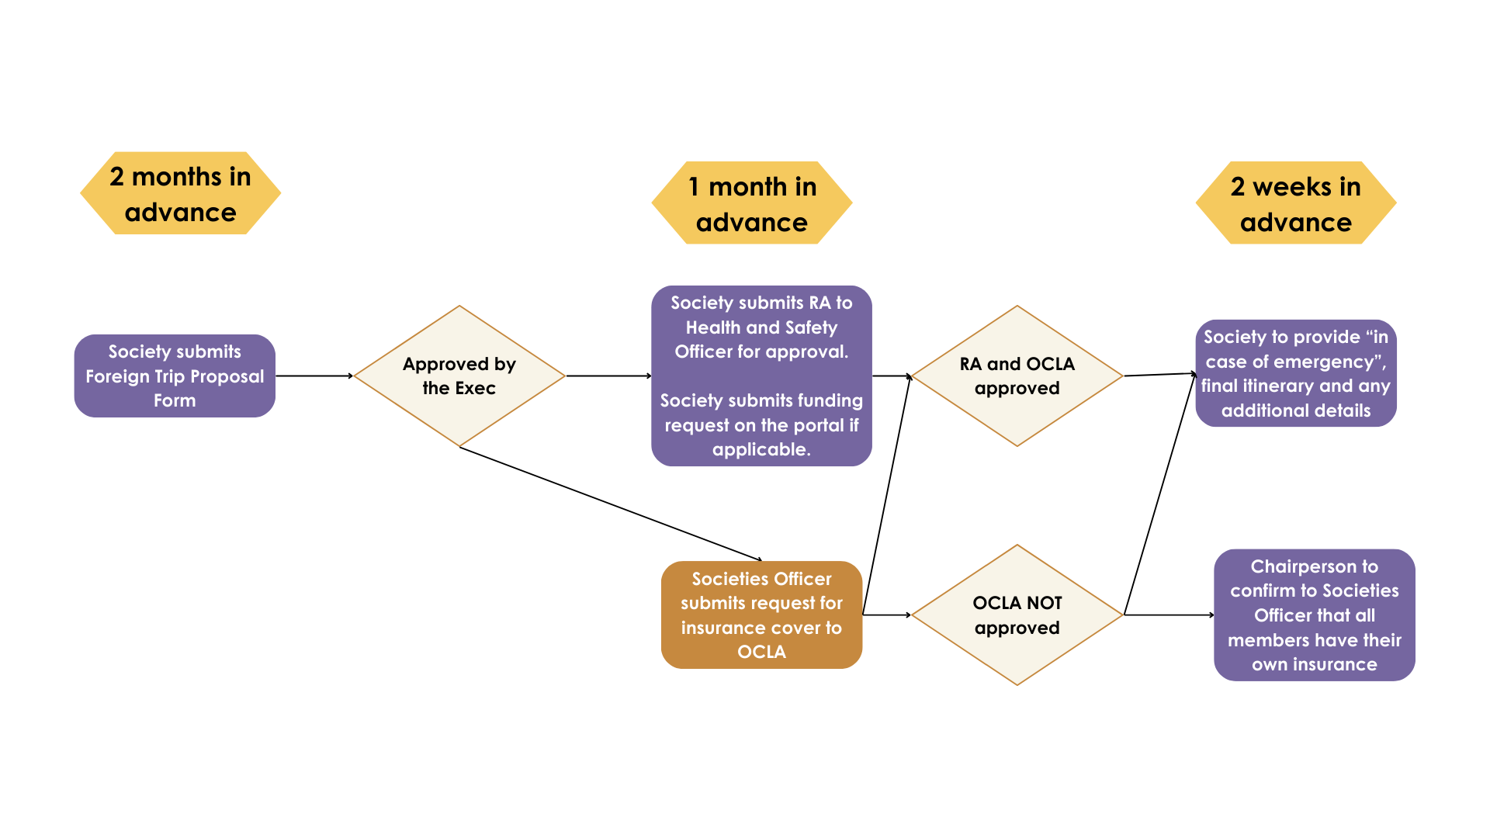

**To reiterate- unless the above points are completed you will be travelling on an unsanctioned trip and to do so will result in the society being sanctioned heavily.**

|  |  |
| --- | --- |
| **Part A – Trip Details** | |
| **Name of Society** |  |
| **Dates for Trip** |  |
| **Trip Location** |  |
| **Number of students travelling** |  |
| **Destination & justification for choosing this location** |  |
| **What is the developmental reason for this trip?** |  |
| **How much is the overall cost – a good estimate based on quotes will suffice** |  |
| **Is this the first time this trip is proposed? Or is it an annual or biennial trip?** |  |
| **How will you advertise this trip?** |  |
| **How do people sign up for the trip?** |  |
| **Are there selection criteria/cap on the numbers travelling?**  **N.B. All the people going on this trip must be members of the society.** |  |
| **What is the breakdown (Undergrad/Postgrad) of the different membership types?** |  |
| **Method of fundraising for the trip if applicable** |  |
| **This is a developmental training trip. At no stage should anyone leave the group to go and do their own thing without telling at least two people in charge.** |  |
| **If the event is being run by another party/company, detail here** |  |
| **Detailed Travel Arrangements**  **and itinerary (If Available) THIS IS NOT A HOLIDAY!**  **You must email the itinerary to all members going on the trip and it must include everyone’s contact details.** |  |
| **For overnight trips, a health declaration should be completed by each of the travelling party. The declarations should be stored confidentially for the duration of the trip and either returned to the relevant travelling parties or destroyed immediately after returning from the trip. This is the responsibility of the trip organiser. Please confirm your understanding - Y/N**   * [UCC Student Activity Health Declaration Form](https://www.ucc.ie/en/media/support/studentexperience/healthandsafetyforstudentactivity/UCCStudentActivityHealthDeclarationForm.docx) |  |

|  |
| --- |
| **Required ICE Details** |
| At least **2 weeks prior** to the trip, an email must be sent to your elected Societies President ([president@uccsocieties.ie](mailto:president@uccsocieties.ie)) and Societies Officer ([societiesofficer@ucsocieties.ie](mailto:societiesofficer@ucsocieties.ie)).  Detailing:   * The finalised day-to day itinerary for the trip * Flight/Ferry details, accommodation name, address and contact number * Details of nearest Embassy and hospital * Screenshots of the membership profiles and contact numbers of those travelling * Emergency contact name and number for next of kin of each person travelling * European Health Insurance Card (EHIC formally E111) for each person travelling * Confirmation that Event Manager has Health Declaration Forms of all participants   **To Note:** We ask EU-born students to ensure they have the EHIC with them when travelling within the EEA as it is automatically recognised (faster treatment than any insurance policy). Any non-EU born students will be covered by UCC Foreign travel insurance if approved. |

|  |  |  |  |
| --- | --- | --- | --- |
| **Part B – Trip Organisers** | | | |
| **ROLE** | **NAME** | **CONTACT DETAILS** | **ROLE** |
| EVENT MANAGER / COORDINATOR |  |  |  |
| EVENT SAFETY COORDINATOR (PERSON  RESPONSIBLE FOR SAFETY) |  |  |  |

**IMPORTANT: Please download the Insurance app prior to travel.**

*Foreign Travel –* ***UCC Insurance App.***

*This is an App for easy access to the UCC travel insurance when away on Club/Soc/SU trips abroad. The app is red - AIG Travel Assistance*

*As trip leader, you should download it onto your phone prior to travel, in case of emergency.*

*I attach info regarding usage, but basically there is a red phone call icon on it which you can use if there is any emergency whilst abroad.*

*The details you need to log on are the society’s email address, the policy number: PAE61285 and it is Ireland - Lifeline Plus*

*Ensure the password is not personal as it will be used by other trip leaders in the future, but do not share it with anybody outside of trip leaders/captain/Chairperson/Dept*

*Do not encourage other members of the group to download the app, it is just for the trip leader in case of emergency & only to be used for authorised UCC trips.*