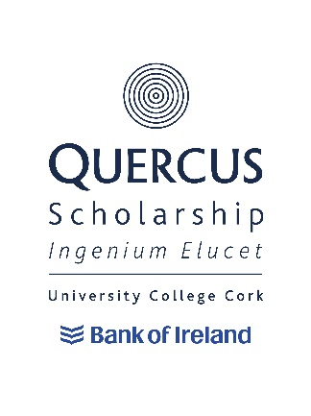
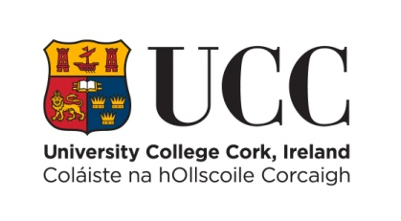
+

Quercus University (Academic) Scholarship
2024/25 Criteria and Terms of Reference

- General Criteria

University College Cork is pleased to announce that up to 4 Quercus Academic Scholarships will be awarded to registered undergraduate/level 8 students in 2024/25 who can demonstrate an exceptional level of academic excellence and who have successfully been selected by the Scholarship Panel for a Quercus Scholarship.

Scholarships will be offered to applicants who satisfy the Scholarship Panel (and in turn UCC) as to their suitability to the Quercus Talented Students’ Programme and who can demonstrate academic excellence. The panel’s decisions will be final. However, feedback on any individual student can be requested.

The Scholarship can be renewed for subsequent years subject to the Scholar meeting the requirements of the Retention and Discontinuation Document and progression to the next level of study in their academic programme.

Scholars may not hold a Scholarship during an academic year spent abroad or on work placement. Renewal will be decided at the end of the academic year prior to the year spent abroad or on work placement and will be “carried forward” to the year after the academic year spent abroad or on work placement.

Scholars will be expected to act as ambassadors for UCC in terms of their participation in academic activities and in their participation in activities designed to promote the Quercus Talented Students’ Programme.

- Applying for a Quercus Scholarship

Potential University Scholars will be invited to apply, by their departments, based on their end of year University results.

Successful applicants will:

- Show outstanding achievement within their discipline(s) and will normally be the highest scoring student in continuous assessment and end of semester examinations in the programme of study and may have been recognised through internal prizes/awards.
- Show evidence of provincial, national, or international achievement.
- Show evidence of participation and engagement with the programme of study.
- Show evidence of communication skills, dissemination and engaging with/mentoring peers, related to the discipline (e.g. oral presentation, poster presentation, publication).

Successful applicants may:

- Demonstrate excellence in areas not exclusive to their specialist domain.
- Demonstrate what contribution they may make as a Quercus University Scholar.
- Demonstrate evidence of leadership and initiative.

Where there are equivalent levels of excellence applicants deemed able to contribute most to the Quercus Talented Students’ Programme UCC will be selected.

Quercus Academic Scholarships
MEMORANDUM OF UNDERSTANDING

Scholars can expect:

- A email confirming the award of the prestigious Scholarship;
- The opportunity to work with a mentor from within or outside the University to help the development of their academic achievements;
- The opportunity to work with a mentor from within the University to help ensure that a healthy and appropriate lifestyle balance is maintained whilst at University College Cork;
- The renewal of the Quercus Scholarship on an annual basis (excepting years spent abroad or on a work placement) subject to adherence of the terms and conditions.

As a Quercus Scholar of UCC you must agree to abide by the following terms and conditions. Failure to abide by the following terms and conditions may result in your Scholarship being revoked with immediate effect.

Scholars will be required to:

- Engage with, and participate in, the activities of the Quercus Talented Students’ Programme as advised to them from time to time;
- Be available to meet potential undergraduate/level 8 applicants at one University Open Day per academic year;
- Be available as a peer mentor where required;
- Support the University’s overall student recruitment strategy;
- Play an active role in UCC where appropriate;
- Be a positive ambassador for UCC at all times including the promotion of UCC in any external interviews or publications associated with your field.

In order for the scholarship to be renewed, the scholar must fulfil their obligations as per the Retention and Discontinuation Document and must progress to the next level of study.

Withdrawal or Suspension of Studies and Repeat Years

Withdrawal

Scholars who withdraw from their scholarship commitments or from UCC will have all future scholarship payments/benefits cancelled.

If you withdraw, at any point during the teaching term, scholarship payments/benefits which have already been made will be reclaimed on a pro rata basis. Under exceptional circumstances, this decision can be reviewed by the Chair of the Panel and approval given for the student to retain any overpayments.

Suspension of Studies

Scholars who suspend their scholarship commitments or academic studies will have all future scholarship payments/benefits cancelled.

If you suspend your studies at any point during the teaching term, scholarship payments/benefits which have already been made will be reclaimed on a pro rata basis. Under exceptional circumstances, this decision can be reviewed by the Chair of the Panel and approval given for the student to retain any overpayments. Mitigating circumstances for the re-instatement of the scholarship may be put forward for consideration by the Chair of the Panel. The remaining yearly balance will become payable on resumption of academic and scholarship commitments.

Repeating an Academic Year

Scholars who are required to repeat an academic year will not receive scholarship payments/benefits during the repeat year of study. Scholarship payments/benefits would recommence once the recipient has progressed to the next level of study and is meeting their scholarship commitments.

Exceptional Circumstances

Students withdrawing from, suspending or repeating their studies, due to illness, bereavement or other exceptional circumstances will be dealt with on a case by case basis.

