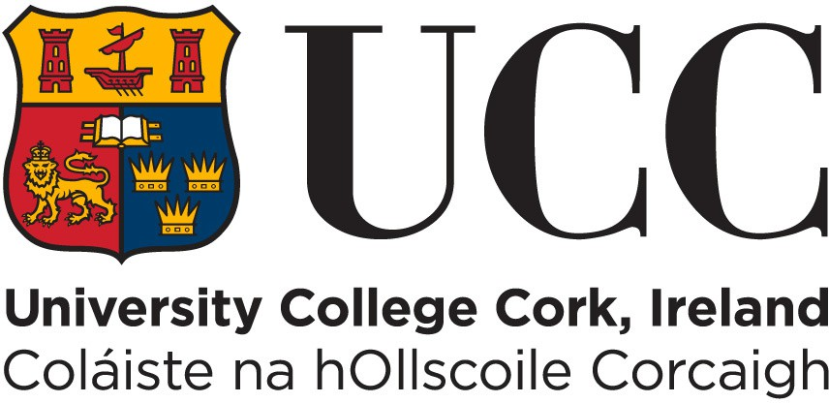

University College Cork

REQUEST TO BE PAID ELECTRONICALLY VIA PAYPATH

Employee First Name and Surname

Employee Address

Staff No. (existing staff only)

PPS Number
* PPS Number is 7 digits and 1 or 2 letters

Bank Name

Bank Address

Name In Which Account is Held

IBAN
* You can check your IBAN

BIC

Employee Email Address

Employee Phone Number

Employee Signature (original or digital)

Date

New Staff please return to your department manager / administrator Existing staff please email to payrollqueries@ucc.ie by the 15th of the month

STAFF RECORDS FORM

Personal Data

Forename: | Title: Mr. □ Mrs. □ Ms. □ Prof. □ Dr. □
Surname: | Date of Birth:  (e.g. 01 SEP 66) | D | D | M | M | M | Y | Y
Home Address: | Sex: Male □ Female □
 | Home Tel No: ( )
 | Work Tel No: ( )
 | PPS No:
UCC Staff No:
(if known)
Civil Status: Single □ Married □ Divorced □ Separated □ Widowed □ Civil Partnership □ Dissolved Civil Partnership □ | Nationality:
Spouse Name:

Emergency Contact Details

Emergency Name: | Relationship to employee: | Emergency Tel No (1):
Emergency Address: |  | Emergency Tel No (2):

Dependent Details

Names: | Dates of Birth: | Relationship to Employee: | Sex:
 |  |  | Male □ Female □
 |  |  | Male □ Female □
 |  |  | Male □ Female □
 |  |  | Male □ Female □

Third Level Education

Qualifications Obtained: □ Doctorate □ Masters □ Primary Degree □ Higher Diploma □ Diploma □ Certificate □ Professional Qualification □ Secretarial Course

□ Other (please specify) ____________________
Title of Qualification/Year Awarded/Institute | Abbreviation (e.g. BSc)

