* INTERPRETATION - "Department" means College/School/Department/Centre/Unit as relevant.
18.3.1 GENERAL
The rapid and expanding use of computer technology and Visual Display Screen Equipment (VDSE) in all areas of industry, commerce, education and information systems such as the Internet and e-mail, that many employees may be at risk from a number of attributed VDSE health concerns and ergonomic difficulties. As a result, legislation has been enacted to ensure employees are made aware and protected from any risks to their health and safety.
The principles and checklists set out below should be applied to risk assessments done on both work offices on campus and home office arrangements, as the same methodology applies to both. A new VDSE RA template can be found here. The new template provides helpful information for assessing risks regarding standing desks and laptop dual-screen usage.

18.3.2 LEGISLATION
Current health & safety legislation gives effect to the mandatory requirements for employees, who habitually use display screen equipment as a significant part of their normal work. The Health & Safety Authority (HSA) has defined this category of users as one who regularly uses VDSE for one or more continuous hours per day. (The term 'employee' covers permanent, fixed term/contract and temporary employees).

Employers Duties
- Employers are required to perform an analysis and evaluate health and safety at the workstations, with particular reference to eyesight, ergonomics and mental stress
- Ensuring that employees are properly trained and educated in the use of the workstation and given information about health and safety factors.
- Employees must also be allowed to have periodic breaks away from the VDSE or change in routine.
- Employees are entitled to an appropriate eye and eyesight test (or may opt for either) before working with the VDSE and at regular intervals. VDSE users have similar entitlements, if they experience visual difficulties.

18.3.3 HAZARDS ASSOCIATED WITH VDSE USE
The most common complaints arising from work activities with using computers are:
- Musculoskeletal discomfort and repetitive strain injuries, now collectively referred to as Work Related Upper Limb Disorders (W.R.U.L.D.).
- Eye fatigue and discomfort.
- Fatigue and Stress.(see Section 18.14 Occupational Stress)
- Other less common concerns include electromagnetic radiation related to CRT (cathode ray tube) monitors only, facial dermatitis and photosensitive epilepsy.

18.3.4 RISKS
The risks associated with the aforementioned hazards are to be assessed by the Department (using the appropriate technical input where necessary). These assessments shall be carried out using:
- Check lists provided (where applicable) and
- Departmental Hazard Identification/Risk Assessment Work Sheets contained in Document No.3 i.e. Departmental Hazard Risk Assessment (D.H.R.A.).

18.3.5 ARRANGEMENTS AND CONTROLS REQUIRED
These hazards and risks will be minimised by the following arrangements and controls:
- All staff must be fully trained with the use, good practice and precautions to take when using VDSE. The instruction must include how the user may carry out risk assessment of the workstation and handouts showing the minimum legal requirements.
- Written assessment of the workstations to be carried out, after training, using the checklist in Section 19.3.4 covering the main requirements of legislation. Deficiencies found must be corrected as soon as practicable.
- All VDSE workstations must meet the minimum requirements as set out in the relevant Schedules. These requirements include the various components of the workstation from chairs to display screens etc. to the general environment including lighting, noise levels, heat radiation and humidity. (See Section 18.1.4 Office Environment requirements.)
- Using the illustrations overleaf, as examples of good workstation layouts (extracted from the H & S Authority guide).
- The design of each VDSE work-station to take account of the equipment provided, the nature of the work and the size/physique of the operator(s) (See Appendix XV Issues and requirements related to VDSE equipment)
- The organisation of jobs so that computer use is interspersed with other tasks such as filing, writing, etc. Failing this, planned five-minute breaks, which rest the eyes, should be introduced every hour.
- Consultation and discussions with staff in relation to hazards and proposed improvement measures

Examples of Workstation Layouts
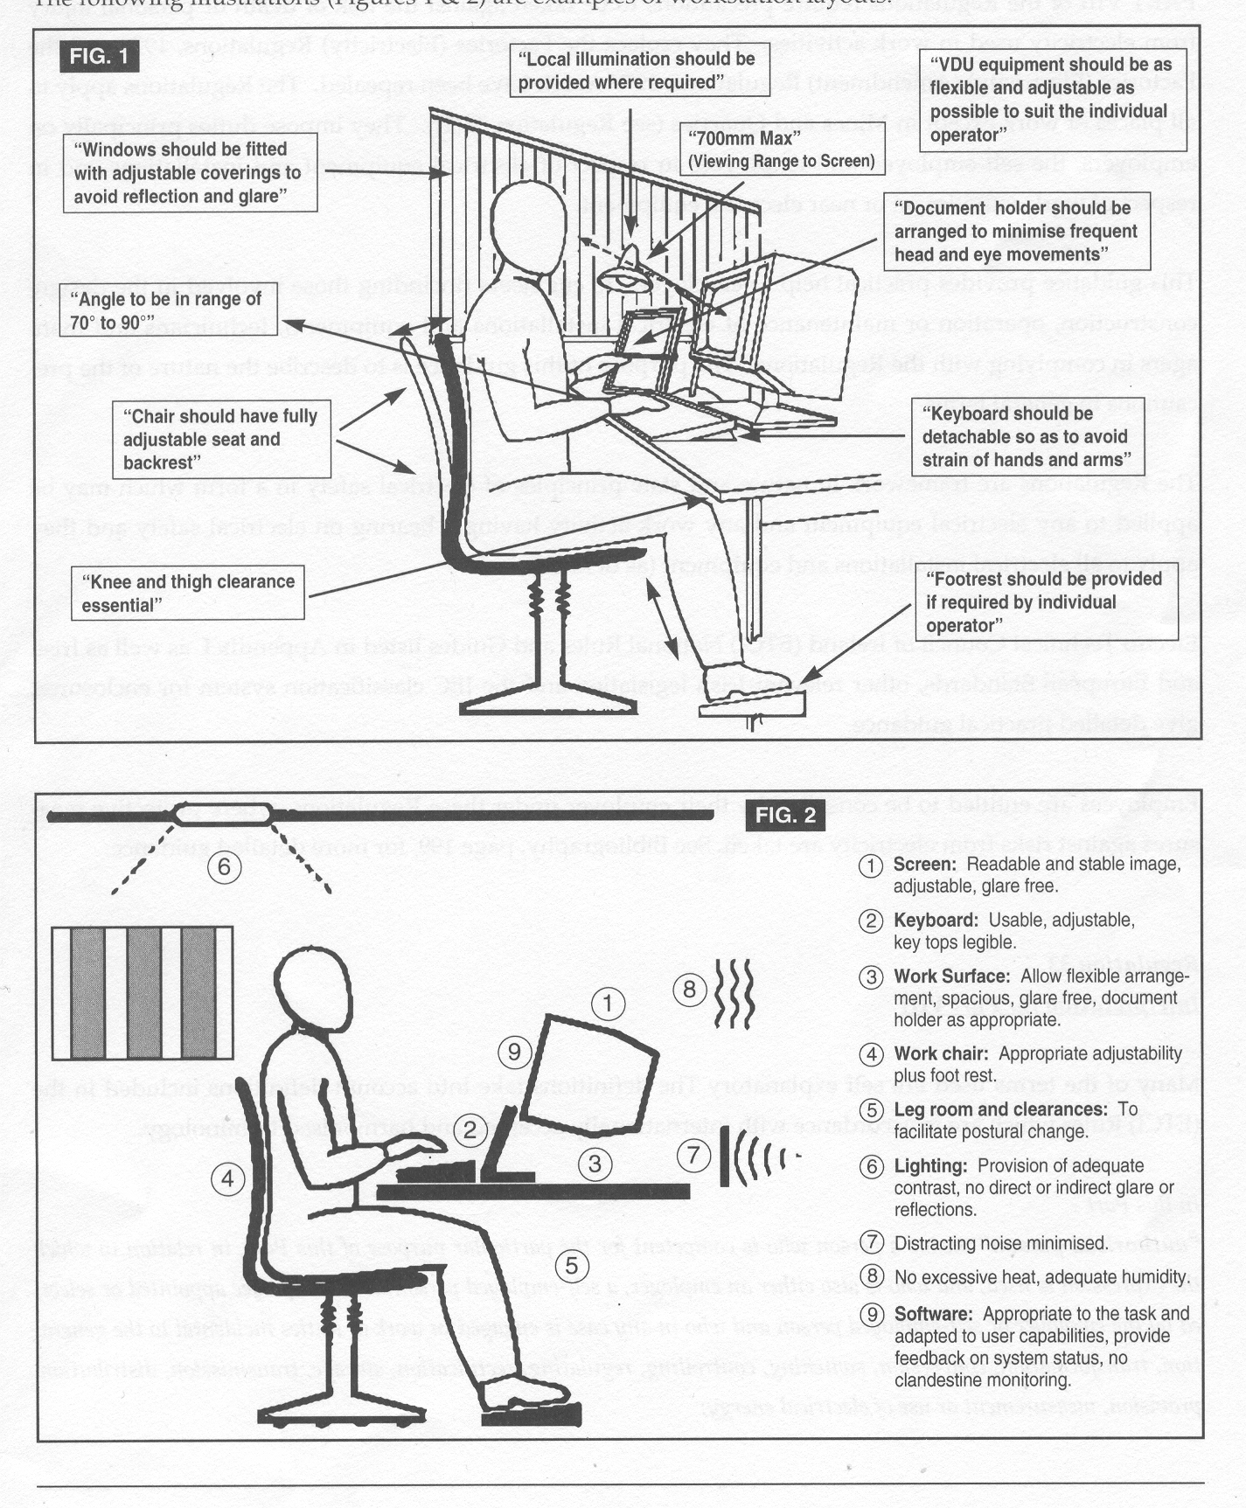

18.3.6 ARRANGEMENTS AND CONTROLS
The details of the Arrangements and Controls in place and those required in the short, medium and long term, shall be set out by the Department in the forms provided in Document No.4 i.e. Departmental Safety Action Plan (D.S.A.P.). These Arrangements and Controls shall be reviewed and updated on a yearly basis.

18.3.7 RESPONSIBILITIES
The following personnel are responsible in the Department/Office/Area for ensuring the implementation and ongoing compliance with the aforementioned arrangements and controls.

AREA/LOCATION | PERSON RESPONSIBLE
1.
2.
3.
4.
5.
6.

