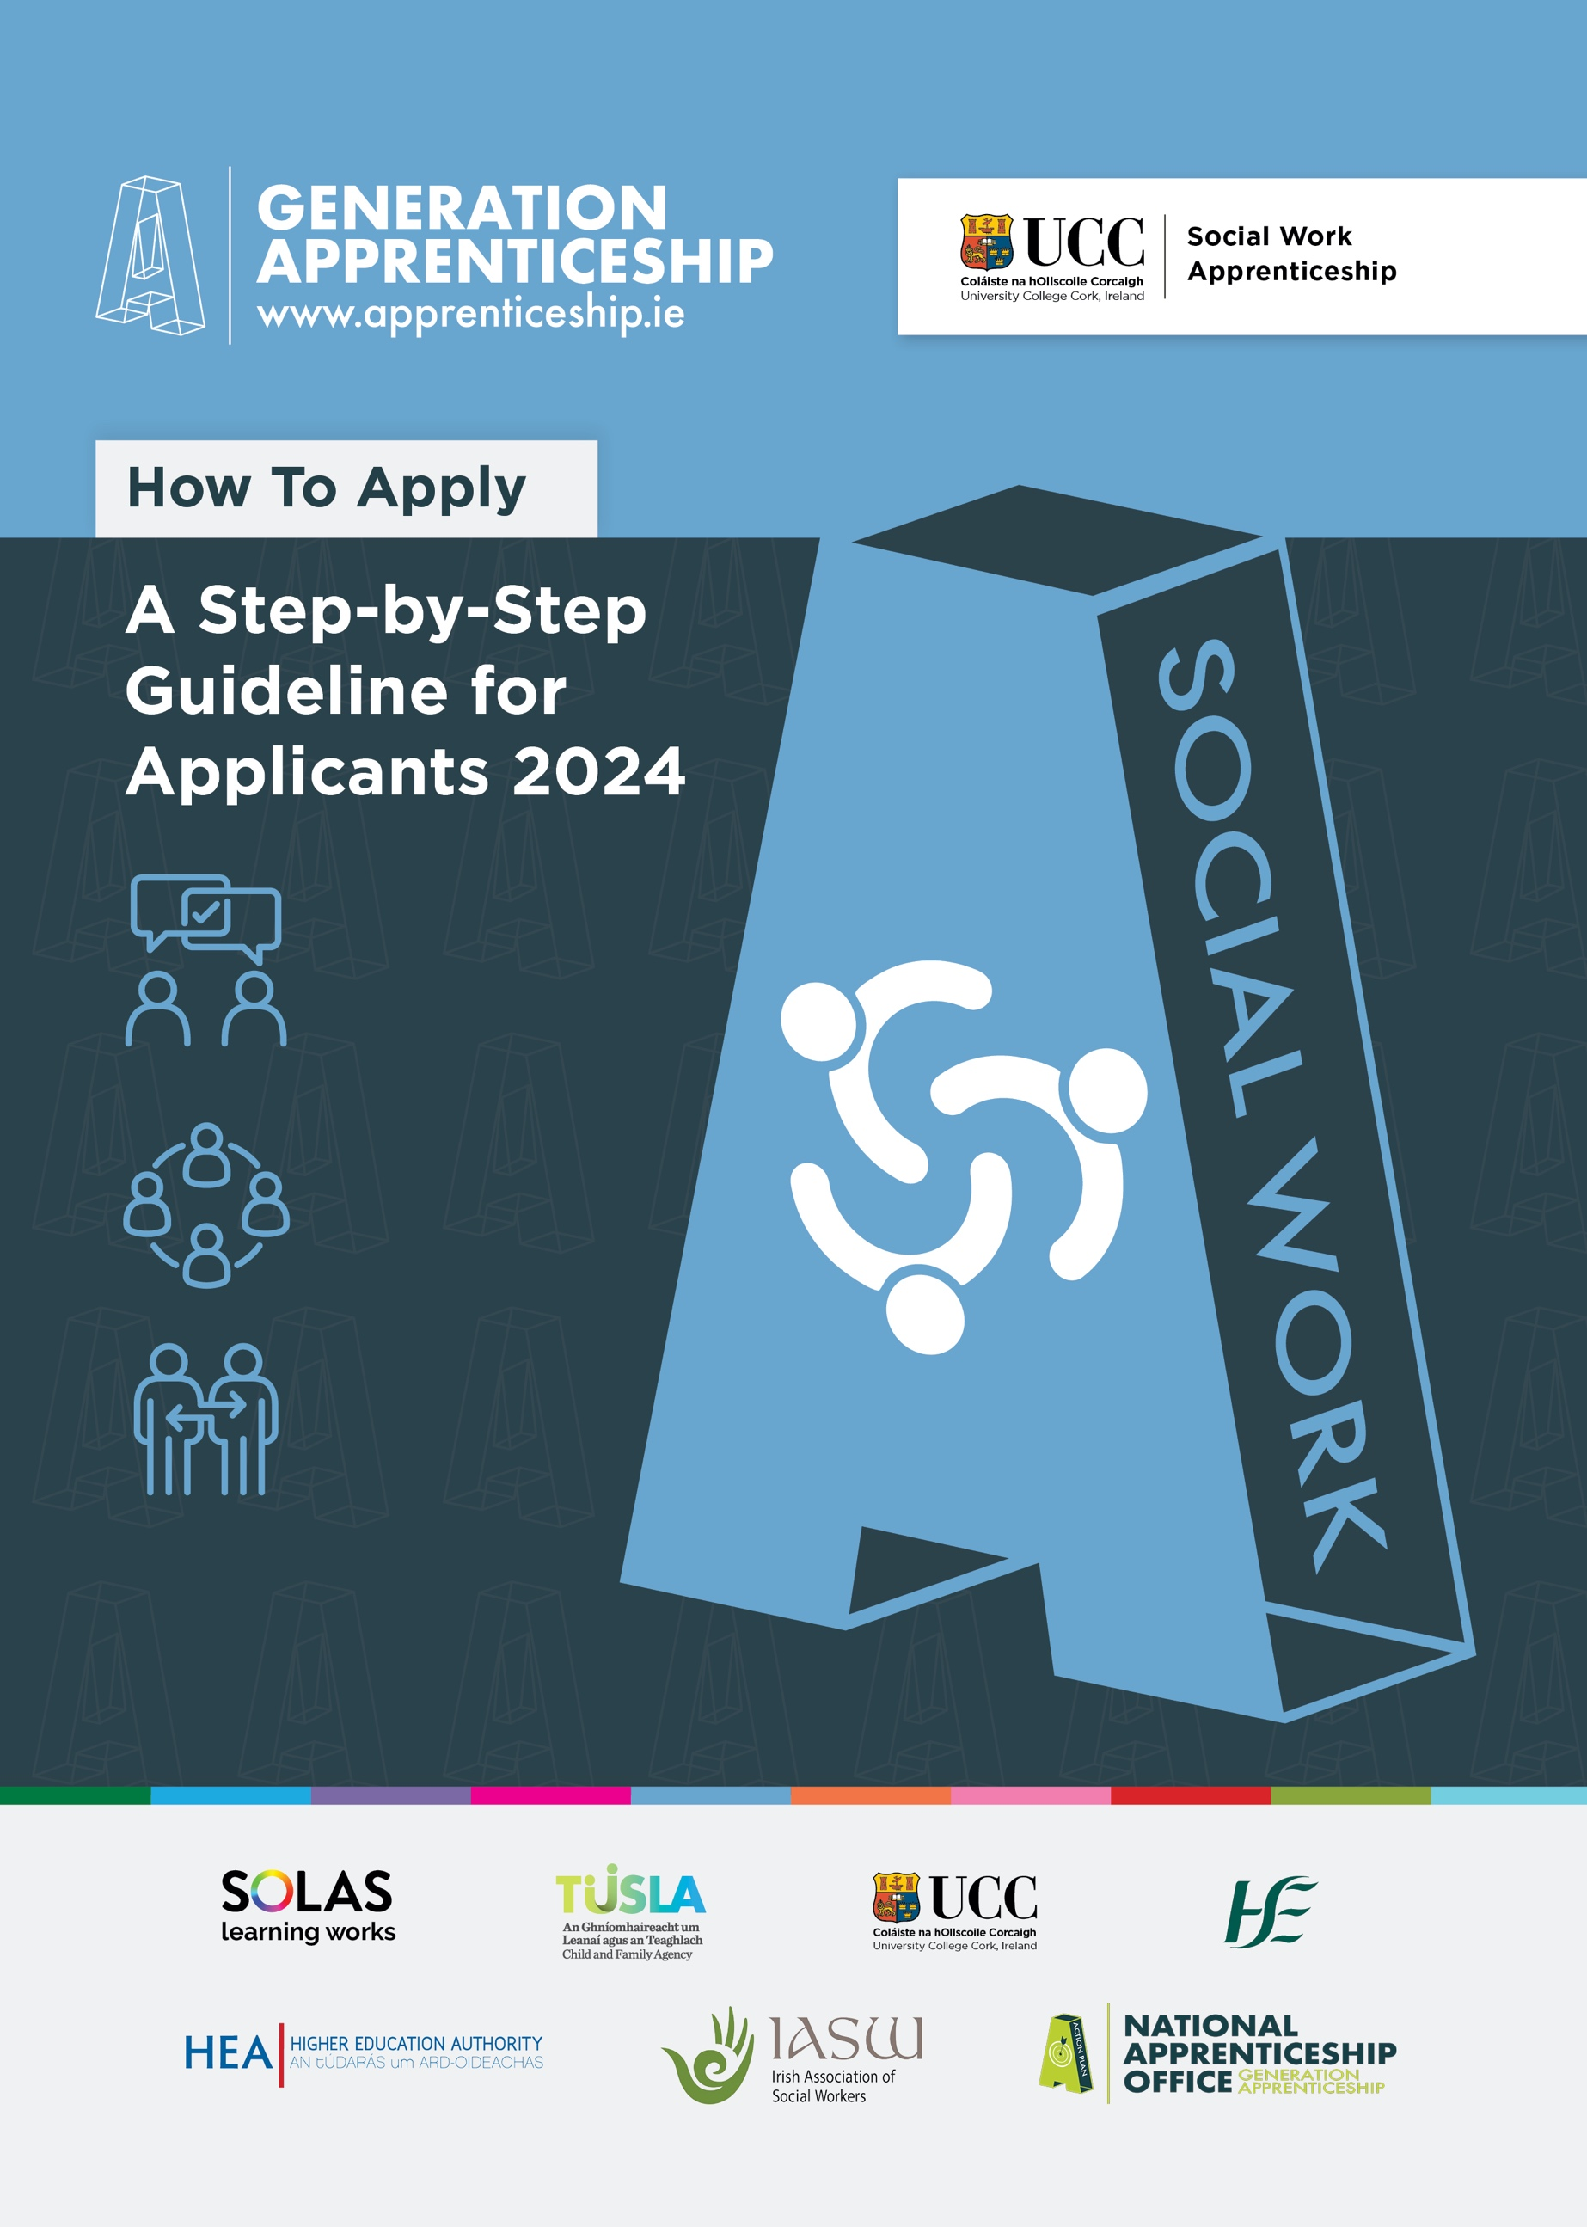

Apprenticeship in Social Work

How to apply

A Step-by-Step Guideline for Applicants

2024

Purpose of this Guideline
This document aims to help you prepare your written application for a post as an Apprentice in Social Work by guiding you through the form in a step-by-step manner. This is just a preparatory guidance note – if there are any differences between this guidance and the final application form that is published, follow the directions on the application form.

Step 1 – Read up about the Apprenticeship in Social Work
Familiarise yourself with the Apprenticeship in Social Work role by reading the Job Specification a number of times and the Apprentice handbook.

Step 2. Gather the Necessary Documentation
Please gather the necessary certificates and information required to complete all areas of the Application Form.

Step 3. Make a note of the designated closing date and time.
Late applications will not be accepted beyond this date.

Step 4. Tech-check
You will need access to the following IT to complete this application:
Microsoft Word
You will need to be able to use Microsoft Word. You will be required to submit your application in a typed Word document.

Google Account, Google Forms
Your application will not be complete until you submit your completed word document via the Google Form link on UCC’s apprenticeship website ( https://www.ucc.ie/en/apprenticeships/sw/). To do this you will need a Google account with a @gmail.com email address. You can set up a Google account easily and for free here: https://www.google.com/account/about/.

Internet access
Because you are applying online, you will need to have access to the internet on the day you submit your application. Remember, late applications will not be accepted beyond the closing date and time even when due to poor connectivity.

Microsoft Teams
Shortlisted candidates will be invited to an online interview via Microsoft Teams.
Please ensure that you have downloaded the Microsoft Teams app in advance of your interview because we advise against using the web-browser version.
Please take time to reboot your device (desktop or laptop) and your internet modem in advance of the interviews to ensure connectivity.

Step 5 The Application Itself – What to expect.
When available, the application form is a word template, which you will be able to download and save to your PC/laptop. The application form is detailed and there are a number of parts – all of which need to be completed:

- Applicant Details
In this section, you will be asked to provide:
Your name and address,
One mobile phone number,
One email address (please use the @gmail.com address you will have to use to upload the completed form).

- Consent – Privacy Notice, Garda Vetting/Police Checks & Fitness to Practise
- Privacy Notice
The Apprenticeship in Social Work recruitment campaign is a collaboration between University College Cork (UCC), the Health Service Executive (HSE) and the Child and Family Agency (TUSLA). You will be asked to consent to sharing of the data on your application form with the partner organisations.
There will be a detailed explanation of the Privacy Notice in Appendix 5. Please review this.
- Garda vetting/Police Checks
You will also be asked to give your permission for the university and host employer to enable police checks on you.
- Fitness to Practise
If successful in this campaign, you will be employed as an Apprentice in Social Work. You will also be a registered student in University College Cork during the apprenticeship, and you will be subject to the University’s fitness to practise policy. You will be asked to tick that you are aware of this.

These consents are very important – take time to read over them as well as any related policies (such as Appendix 5 and employer policies etc) before answering the consent forms.
Employer Preference
Two national employer organisations are involved in the Apprenticeship recruitment campaign in 2024 - TUSLA are offering 25 apprenticeship. The HSE are offering 12 apprenticeships. In this part of the form, you will be asked to indicate your preferred employer. You will be asked to select only ONE of the following three options to indicate your preference:
  - TUSLA only or;
  - HSE only or;
  - Both TUSLA and HSE.

- Location Preference
TUSLA and HSE have identified priority locations nationally for employing apprentices in 2024. The locations will be listed in each of the job specifications from the employers.

In this part of the application, you will be asked to indicate your preferences in APPENDIX 3 where all the locations will be listed for each partner organisation.

You will be asked to select your top 3 preferred locations in Appendix 3 – one of which can include a location not listed by the organisation (you will be asked to name location in an ‘Other: Please specify’ box in the list of locations).

If you are applying for both HSE and TUSLA, please indicate your top 3 locations for each employer.

Please note apprenticeship offers will be made by order of merit and in line with organisational need, therefore it may not be possible to facilitate applicants' preferences.

- How did you hear about the apprenticeship in social work?
In this part, you will be asked about how you first became aware of the apprenticeship. You will be asked to tick the box that best applies to you. This will help us to focus future recruitment campaigns for Apprenticeship in Social Work.

- European Economic Area/Nationality
In this part you will be asked to identify the status of your nationality (EEA/British/Swiss/Non-EEA Notional). Additional information about requirements in this part will be found in Appendix

- Academic Qualifications and Eligibility Criteria
7a. You will be asked to indicate your academic eligibility to apply for the Apprenticeship in Social Work.
You must choose one of three options that matches your status:
- You are a graduate with a 2:1 level 8 degree in Social Science or its equivalent or Graduate with an approved level 8 conversion programme (Higher Diploma in Social Policy) and 3 months’ relevant work experience;
- You expect to graduate in 2024 with a 2:1 level 8 degree in Social Science or its equivalent or Graduate with an approved level 8 conversion programme (Higher Diploma in Social Policy) and will have a 3 months’ relevant work experience by August 2024;
- You are submitting your application for consideration under Recognition of Prior Learning.

7b. Recognition of Prior Learning (RPL) is relevant only if you are applying under 7a.iii above. RPL is a process by which prior learning is formally identified, assessed, and acknowledged. This makes it possible for an individual to build on learning achieved and to be rewarded for it. Prior learning is learning that has taken place but has not necessarily been assessed, measured, or assigned credits. You are eligible to supply an application for consideration under the Recognition of Prior Learning if you:
- hold an honours primary degree (NFQ, Level 8) in any discipline, and have completed a minimum of twelve months’ relevant work experience in a social work or social work-related field;
or
- hold a primary ordinary degree (NFQ, Level 7) in social science or its equivalent with an overall result of at least a Second 2:1 grade and have completed at least three years’ experience in a social work or social work-related field;
or
- non-graduates with at least five years’ professional experience in a social work or social work-related field may also be considered for admission.

If you are applying through this criteria, you will be required to also complete a RPL form in Appendix 1 which will be assessed by trained UCC-staff. Please see the RPL form in Appendix 1.

- Educational Achievements
In this part, you will be asked to list all education awards you have achieved and expect to receive if graduating in 2024 in chronological order. You will be asked to start with your most recent award to finish with your oldest award (i.e. the final education award you received at post-primary level).

Tip: When you are gathering all the dates for these awards, collect certified copies of original documents because, if successful, you will need to supply them before a post can be formally offered to you and you will need to supply them to UCC as well.
- Work experience/Career History
In this part you will be asked to provide details of your full work experience and to outline your main roles and responsibilities.
Tip: Take time to think about all aspects of work experiences that you bring to this application. Organise these in a chronological way.

- Gaps in Career History
You will also be required to explain the reason for any gaps in your career history (e.g. career breaks, spent time outside of work, travel etc).

- Volunteer Experience
In this part you will be asked to provide details of your full voluntary experience and to outline your main roles and responsibilities. This can include activism, fundraising, community support, volunteering with charities, mentoring, youth support (including sports/youth clubs) etc.
Tip: Take time to think about all aspects of your volunteer experiences that you bring to this application. Organise these in a chronological way.

- Supplementary Questions
In this part, you will be asked four questions related to competencies associated with the Job Specification of the Apprenticeship in Social Work. You will be required to provide responses to ALL 4 questions. When it comes to answering the supplementary questions, consider at all times your experience and qualifications in light of the Job Specification and requirements of the role. Please also see guidance in Appendix 4 of the application before you submit your application.

Give specific examples – most questions will ask you to describe an example of when you have demonstrated a skill: try to do this concisely but with enough detail so that the reader will be clear about what you actually did. This detail might include information about timescales, the number of people involved, resources etc. It can help to use bullet points so that the sequence of events is clear to the reader.

Give a range of examples – base your answers on different situations or challenges you faced rather than rely on just one experience. This helps the reader to evaluate how you tackle different challenges and not just your behaviour in a ‘one off’ situation.

Be concrete rather than theoretical – a clear description of how you actually behaved in a particular situation (and why) is of much more use to the reader than a vague or general description of what you consider to be desirable attributes.

The four questions you will be asked are:
- Professional Knowledge & Experience
Social work is a relationship based discipline which focuses on human rights and social justice. In 300 words or less, please give an example from your experience (paid/voluntary work/activism) which best demonstrates these principles.
- Evaluating Information, Problem Solving and Decision Making
In 300 words or less, please provide an example of a situation which best demonstrates your administrative skills including reference to your competence in the suite of Microsoft applications.
- Teamwork and Commitment to a Quality Service
Social Workers promote change and continuously strive to improve the quality and efficiency of the service. In 300 words or less, please provide an example of a situation which best demonstrates your ability to work collaboratively to achieve a shared goal/ deliver high quality service.
- Planning and Managing Resources
The apprentice will attend academic study in UCC during their apprenticeship training. There will be a requirement to pass all academic examinations and meet CORU standards of proficiency during work-integrated learning/placement blocks, and to maintain records of progression and development. In 300 words or less, please outline why you wish to apply for the Apprentice in Social Work programme including reference to your ability to the manage competing demands/priorities.

- Declarations
In this part, you will be asked to read declarations about the recruitment process and to sign the document. An electronic signature will suffice.

- References
In the final part of the application, you will be asked to name three referees (including your current employer, if appliable). You will also be asked if you wished to be contacted before the relevant partner organisation contacts your referees.

Step 6 Final Submission
When you have completed your application, take time to edit and proof-read your application. Then save your document under your own name Surname_Firstname_ASWapplication.docx (e.g. Jones_Hilary_ASWapplication.docx).
Once saved upload your completed form via the link (Google Form) on: https://www.ucc.ie/en/apprenticeships/sw/ website.
Remember to complete this Application Form in full and return it by the designated closing date and time stated on the Job Specification document. No other versions of applications will be accepted e.g. CV, etc. Incomplete applications will not be considered.

