Review of scholarship of teaching during COVID 19; Problem Based Learning experiences of Dr Irene Hartigan and Siobhan Murphy in collaboration with Dr Nicola Bessell and Dr Tomás Russell.

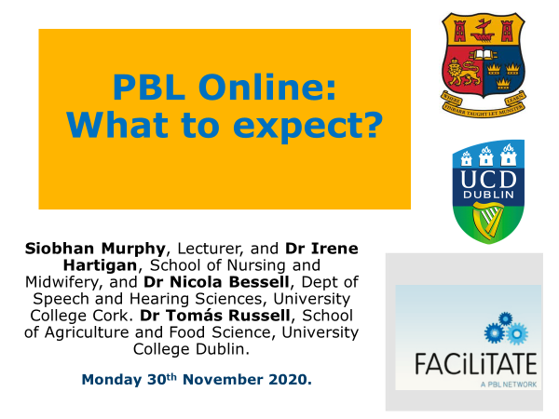

The ethos of supporting people during COVID 19 brought educators from UCC and UCD together to present on their scholarship of delivering PBL online. The unusual mix, of farmers and nurses, both of whom care for people encouraged educators to examine how to pivot to PBL online. Thankfully, the Winter Webinar Series: Strengthening learning during COVID-19 hosted by the national PBL network of Ireland known as FACiLITATE, provided a medium for discussions across several institutions. PBL teaching methodology embodies active learning by students which up until the pandemic predominantly entailed small group teaching within classroom. The safe environment of the classroom encouraged students to discuss, debate, problem solve, hypothesize and challenge thinking for the purpose of solving real life problems situated within their area of practice. However, online PBL conjured up conscious and subconscious challenges for students and educators. This brought a new meaning to the process from addressing technical issues such as the hosting platform, broadband issues and user device choice to fear and adapting behaviour. Fortunately from the opportunity afforded within the webinar series Irene, Siobhan, Nicola and Tomás were able to develop their scholarship of teaching and learning.
Dr Irene Hartigan, Dr Nicola Bessell and Siobhan Murphy presented their personal experiences and reflections from using PBL within an undergraduate health professional module. In conjunction, Dr Tomas Russell, University College Dublin, presented his experiences of a post graduate online module for Family Farm Consultants. The webinar was moderated by Emma O’Brien, chair of FACiLITATE who divided participants into online breakout groups and subscribed discussions using ‘jam boards’. The international audience provided 3 key strategies to foster online PBL which include 1. To keep the problem real to reflect professional practice, 2. Create opportunities for discussion and 3. Encourage students to turn on webcams to foster engagement.
A spring series of webinars will be launched early in the new year so tune into the website and twitter for more information.
For more information follow
Please follow the PBL facilitate network on
Twitter @PBLFacilitate #PBL2020
Website: https://pblfacilitate.wordpress.com/

