My Canine Companion Easing Waiting Time for Patients Receiving Radiation Therapy

The Glandore Centre, at Cork University Hospital, provides radiation therapy for patients over a large geographic area from Cork, Kerry, Waterford to South Tipperary. The logistical burdens of appointment scheduling and travel add to the psychological and emotional distress among patients. As part of the Cork University Hospital Study Day, endorsed by Irish Institute of Radiography and Radiation Therapy association, a very successful day of talks were delivered to develop practices related to radiation diagnostics, holistic patient care and animal radiation therapy. A special plenary session was tailored to animal therapy, Dr Richard Elders, Veterinary Specialist in Small Animal Oncology gave a wonderful presentation on radiotherapy in a small animal hospital setting and this was followed by Elaine Kay, Radiation Therapist from Glasgow vet school, who shared similarities between animal and human radiotherapy. Dr Kate Fitzgerald, MCC handler and radiation therapist presented the results of a 6-week quality improvement (QI) initiative which was undertaken in the Glandore Radiotherapy Centre and in partnership with My Canine Companion (MCC). Evidence suggests that the cumulative amount of time patients spend commuting to therapy and undergoing radiation therapy, each day for several weeks, imposes a significant strain on their day-to-day lives. The aim this QI initiative was to introduce dog-therapy, to the Glandore Centre, to reduce the burden on patients and support patient-staff wellbeing. Prior to introducing MCC Anna to the waiting area patients completed a short survey communicating their preference to the introduction of a therapy dog. MCC Anna attended the waiting area for 2 mornings for 6 weeks and the survey was then repeated. Overall, the implementation of MCC Anna dog therapy programme in the centre had numerous benefits for both patients and staff. It has created a more relaxed and welcoming environment in the waiting area and provided an important source of support for patients undergoing radiation therapy. While there was over 80 members registered for the study day, there were some welcomed special guests MCC handlers Katie Fox, Noirin Moynihan, Letitia Hassett and Nicole Duggan who were joined by MCC superstars Zorro, Sandy, Alfie, Jackie and Mescal. A big thank you to our helpers on the day Bethany Moynihan, Alexandra and Lily who collected over two hundred euro in donations. Also, to Micaela Moynihan for the photos. We look forward to developing this initiative further with the members of the team at CUH Radiotherapy especially, Eoin McGrath, Claire Keating, Claire Harman, Kate Fitzgerald, Derry McCarthy and MCC Anna to explore more actionable outcomes such as anxiety, pain and subjective waiting time. Dr Irene Hartigan was delighted that results were resoundingly positive and is seeking student nominations as part of the School of Nursing & Midwifery Summer Undergraduate Research Awards (SURE) to expand this initiative further.

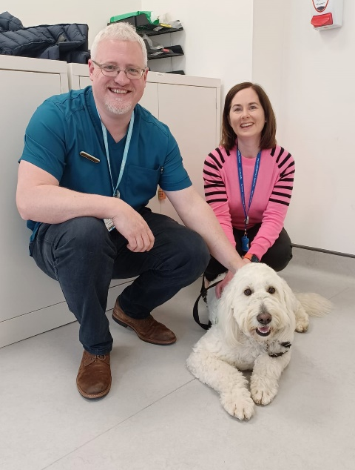
Eoin McGrath & Claire Keating Claire Harman, Claire Harman, Kate Fitzgerald, Derry McCarthy,
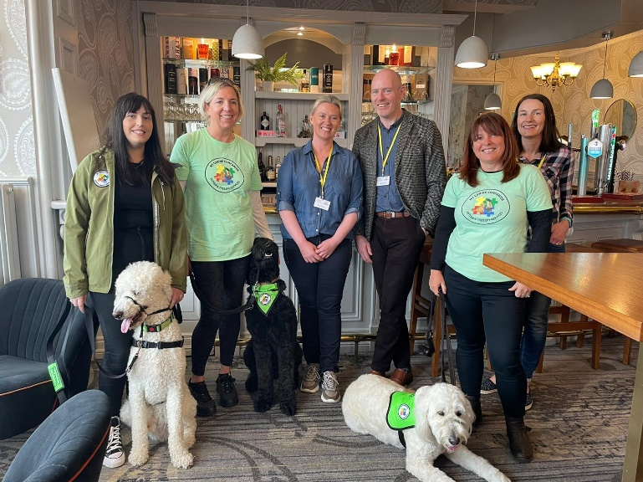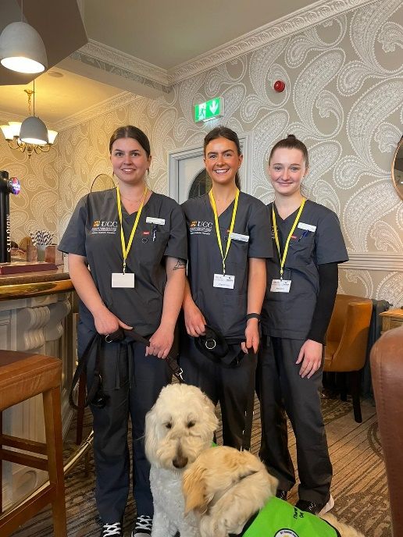
Nicole Duggan, Katie Fox, Kate Fitzgerald, Prof Mark McEntee, Cliona O’Rourke, Irene Hartigan
Ana-Maria Ciocan Aine O'Brien; Margaret Frances Foley with MCC Anna & Jackie

