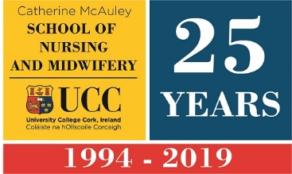
SCHOOL OF NURSING AND MIDWIFERY ANNUAL ACHIEVEMENT AWARDS
NOMINATION FORM 2020
Nominee:
Contact email:
Contact phone:
If applicable: Undergraduate Postgraduate
If applicable: Course of study:
If applicable: Year of study:
If applicable: Area:
If applicable: Job Title:
Nominator:
Please place a in the column below for which award the individual or area being nominated. Use one application form per nomination.
Undergraduate Student of the Year
Postgraduate Student of the Year
Student Leader of the Year
Award for Outstanding Contribution to Student Life
Award for Recognition in Sport
Award for Recognition in the Arts and Entertainment
Community Engagement/Activist Award
Patricia J. Power Excellence in Clinical Practice Award
Preceptor of the Year
Best Clinical & Quality Environment of the Year
Promoting Equality & Diversity Award
In no more than 200 words, please indicate why the above named individual or area should receive the award (please refer to the criteria for each award). Please return the nomination form via email to mgt.murphy@ucc.ie

