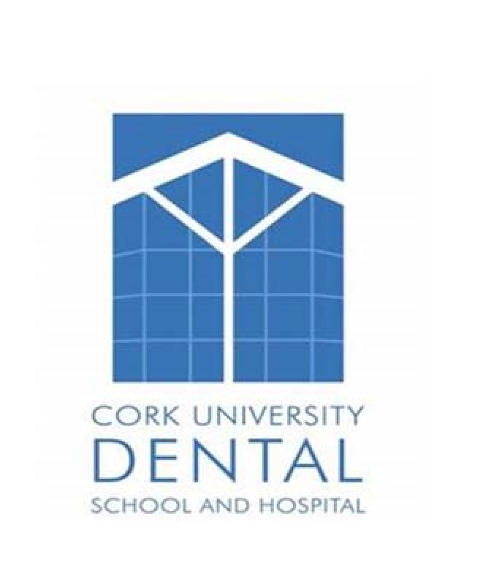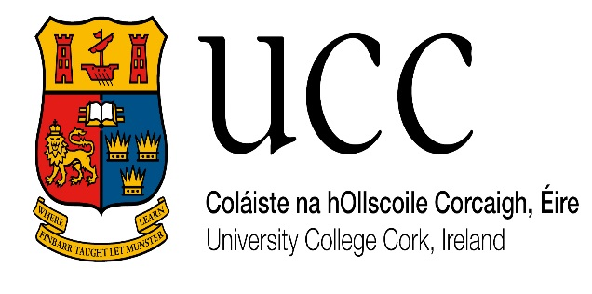

CORK UNIVERSITY DENTAL SCHOOL & HOSPITAL

DENTAL RADIOGRAPHY COURSE 2024 FOR DENTAL NURSES AND DENTAL HYGIENISTS

COURSE OUTLINE

COURSE OVERVIEW
At the end of this course, students should be competent in dental radiographic technique for use in dental practice in Ireland. The theoretical component of the course will be delivered online. The basics of radiographic technique will initially be delivered in University Dental School and Hospital and subsequently supervised by a dentist in practice. A record of all radiographic examinations conducted in practice will be recorded in a log book. Students will be assessed at various stages throughout and at the end of the course. Upon successful completion of the course, Dental Nurses must register with the Dental Council if they wish to use the certificate and conduct radiographic examinations in practice.

COURSE OBJECTIVES
This course will be delivered whereby the students attend the lectures online via MS teams. Practical radiography sessions, radiographic technique and image processing will be done the dental Hospital and continued in dental practice. Students will be encouraged to ask questions of the instructors on the course. The primary objective of the course is that upon successful completion dental nurses and hygienists should be competent to undertake dental radiography to a standard required for general practice in Ireland.

COURSE CONTENT

The course consists of 12 modules and are available online and presented by lecturers from the
X ray Dept., Cork University Dental School and Hospital. Real X-ray images and video clips are used to further your understanding of the topics.

A logbook must be kept by the students to record their clinical experience of taking dental radiographs. This logbook must include the number and types of radiographs taken, the quality rating and identification of any film faults. A minimum quota for the number of views taken, as follows:
25 INTRA ORAL VIEWS
25 EXTRAORAL VIEWS ( Must be 5 Lateral Ceph)
10 ANY VIEW- INTRA/ EXTRA ORAL
The techniques for various views include:
- Occlusal views
- Bitewing
- Panoramic
- Periapical

The course will run on a Tuesday night from 7.30 to 9pm. There is a maximum of 10 nights between August and December to attend for Lectures. There are two continuous assessments which will be done at your practice.
Students will have to attend week of 26th August 2024 for a practical session and Monday 9th December 2024 for the final examination. These dates are provisional and subject to change.
There will also be a practical exam and students will have to attend during a weekday (of their choice) in order to sit the practical component. The 15-minute oral exam will be done online.

ENTRY REQUIREMENT

To enter the Cork University Dental School & Hospital Certificate in Dental Radiography and to enrol on the course, you must be a current student of a recognized dental nurse course or hold a recognized qualification in Dental Nursing or Dental Hygiene.

You will need broadband access to the internet using a computer with audio (either using headphones or speakers) and a webcam. You will be required to have a Microsoft teams account. A current email address is also required.
Finally, you will need
Access to licensed or registered radiographic equipment and the signed support of your dental
Practitioner who is willing to supervise you whilst you take radiographs for your logbook.

For students who do not have access to OPG/ Lateral Ceph in their practice, you will need to arrange with a practice that has this equipment that will allow you to do this practical training at their practice. NB: You will need to have a signed declaration from this practitioner also.
These signed declarations must accompany your application. Failure to include these with your application will mean that you will not be considered for a place on the course.
You will need to able to commit to attend the lectures and the practical training/ exams. These dates are set by the college and attendance is mandatory.

RECOMMENDED READING MATERIAL
Textbook: ‘Radiography & Radiology for Dental Nurses’ by Eric Whaites. Churchill Livingstone

FEES
€1150 per student

CHECK LIST FOR APPLICATION
Completed application form with phone number and email address
Copy of x ray Licence / Registration from EPA
Signed Letter of support for Intra Oral/ OPG/ Ceph
Proof of Dental Nurse / Hygiene qualification or enrolment on an approved course

CONTACT US

Dr Caitriona Ahern
X Ray Department
Cork University Dental School & Hospital
Wilton
Cork
Telephone: 021 4901175
E-mail: caitriona.ahern@ucc.ie

PROGRAMME SCHEDULE

WEEK
1 | Introduction to Programme  Basic and Radiation Physics  - Concepts of Radiation and Atomic Structure  - X-ray Production (online)
2 | Basic and Radiation Physics  - Interaction with Tissue and Bioeffects of Radiation  Radiation Protection  X-ray Equipment  - General X-ray tubes
3 | X-ray Equipment • Dental X-ray tubes Exposure Factors  - Basic and Advanced Concepts  Radiographic Technique  - Indications and Considerations
4 | Radiographic Technique  - Principles of Dental Technique  o Paralleling / Bisected Angle o Bitewing  X-ray Equipment  - Specialised X-ray tubes
5 | Radiographic Technique • Principles of Dental Technique o Occlusal o OPG  Exposure Factors  • Image Quality Criteria
6 | Image Receptors  - Image Production and Film  - Screens and Cassettes  - Digital image Production o Receptors  o Acquisition and imaging chain
7 | Processing  - Film Processing: Principles and Practice  - Chemical Hazards • Film Faults  - Digital Processing  - Digital Hardcopy
8 | Legislation and Dosimetry  - Legislation • Dosimetry  Quality Assurance  - Equipment
9 | Quality Assurance  - Photographic  - Digital  - Clinical Audit
10 | Radiographic Technique  - Radiographic Anatomy  - Radiographic Image Appraisal / Critique
11 | Logbook completion
12 | Logbook completion
13 | Logbook Completion
14 | Logbook Completion
15 | Logbook Completion
16 | On completion of logbook - Competency Assessment (attendance at Cork University Dental School & Hospital - compulsory)
17 | Exit Assessment

